IDEA的快捷键

# 常用快捷键

## 常用跨快捷键

**打开Settings**: Ctrl+Alt+S;  
Alt+向上箭头and Alt+向下箭头：在两个方法之间快速移动；to quickly move **between methods** .

**Ctrl+Shift+J** shortcut **joins two lines into one** and removes unnecessary space to match your code style.将两行整合成一行，并且删除没有必要的空格。

**Ctrl+Shift+V** ：to choose and insert recent clipboard contents into the text.选择性粘贴；

**Ctrl+H** ：观察选择类的继承体系To see the inheritance hierarchy for a selected class；

Use **Alt+Shift+C** to quickly review your recent changes to the project.

The shortcuts such as **Ctrl+Q (View | Quick Documentation),** **Ctrl+P (View | Parameter Info),** **Ctrl+B (Navigate | Declaration)** and others can be used not only in the editor but in the code completion popup list as well.

## IDEA的搜索快捷键

全局搜索Search Everywhere:**Double Shift**；

根据类名搜索类:**Ctrl+N**; (Enter class name)

搜索文件：**Ctrl+Shift+N**; (Enter class name)

搜索符号：**Ctrl+Shift+Alt+N**; (Enter symbol name)(也就是根据文件中某个词汇搜索)

快速查看最近的文件Recent Files:**Ctrl+E**;

**Ctrl+J**：

Use Ctrl+J to complete any valid Live Template abbreviation if you don't remember it. For example, type it and press Ctrl+J to see what happens.

# 查找与替换

**Ctrl+Shift+F：查找**

**Ctrl+Shift+R：替换**

# Debug

### Alt

To quickly evaluate the value of any expression while debugging the program, hold Alt and click this expression to see its value and calculate it, call a method, etc.



# 修改快捷键

导入Eclipse的快捷键。

**File=>Settings=>Keymap**

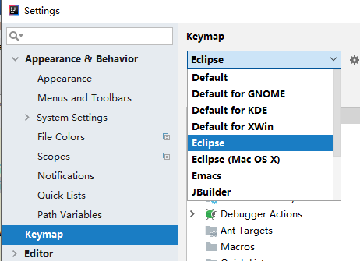

# 快捷键查询

**Help==>Keymap Reference**

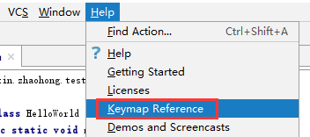

<https://resources.jetbrains.com/storage/products/intellij-idea/docs/IntelliJIDEA_ReferenceCard.pdf>

# 自定义配置

File=>Settings=>Editor=>Line Templates=>**右侧加号**。

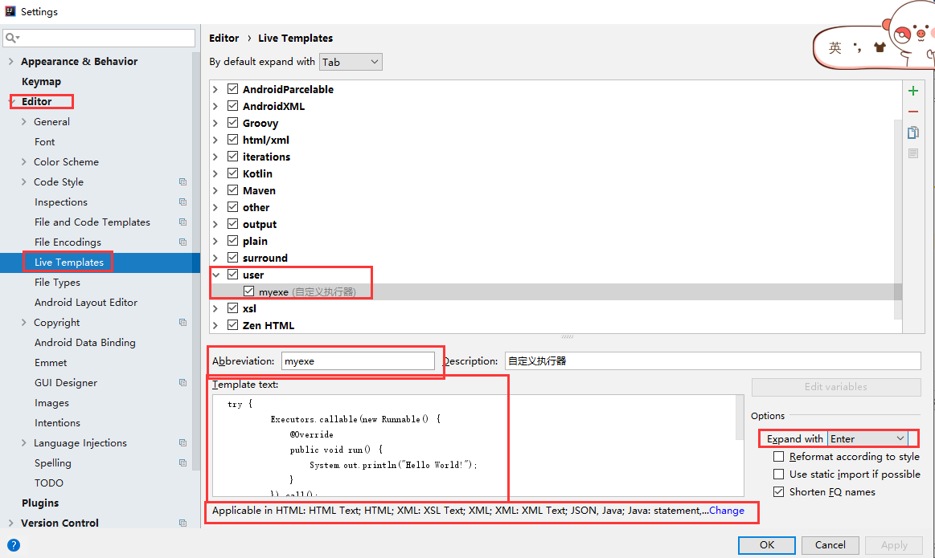

输入myexe回车即可输入指定的Template text。



# 自定义模板

**File=>Editor=>File and Code Templates**

